**Home Publico**

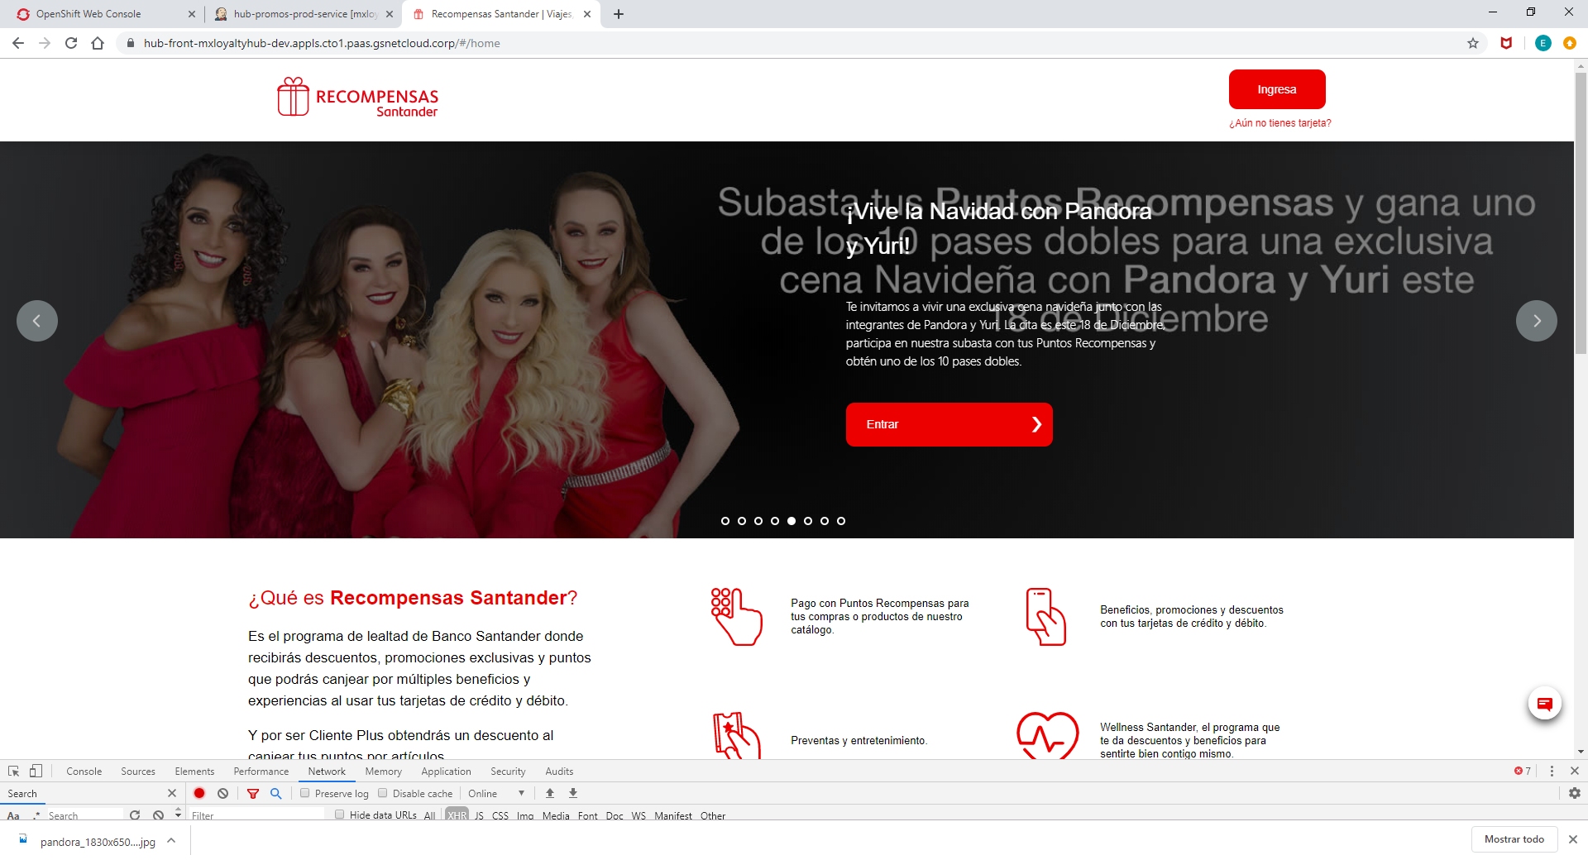

1. **Request URL:**

https://hub-front-mxloyaltyhub-dev.appls.cto1.paas.gsnetcloud.corp/public/promos-prod/sliders/PUBLIC_ONE

1. **Request Method:**

GET

Promocion

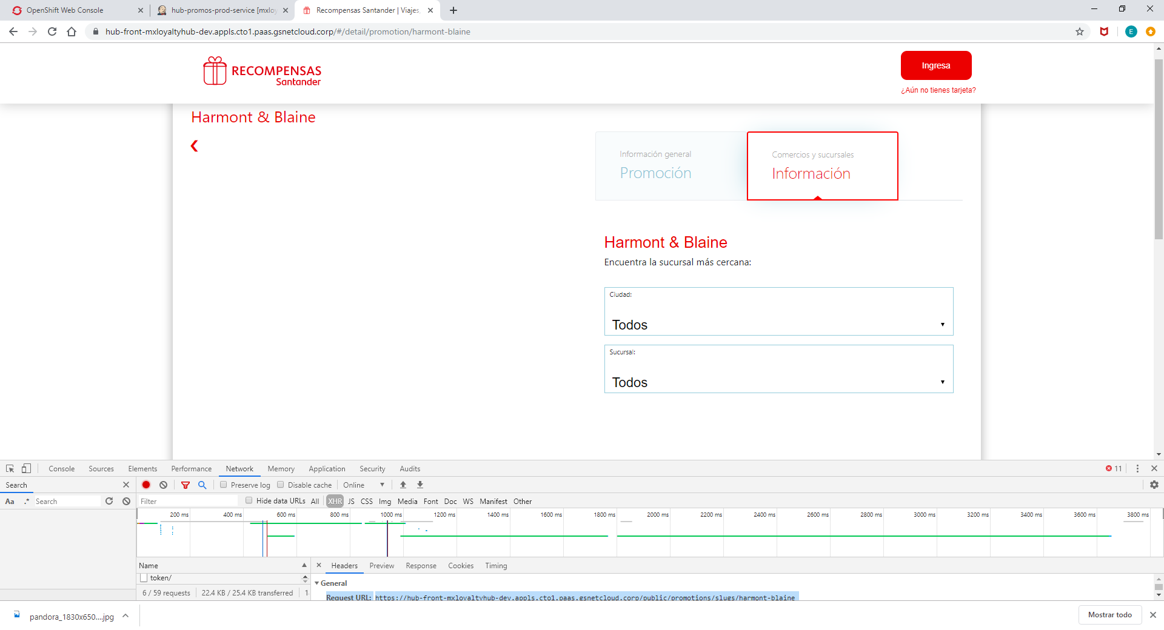

Request URL: https://hub-front-mxloyaltyhub-dev.appls.cto1.paas.gsnetcloud.corp/public/promotions/slugs/harmont-blaine

Request Method: GET

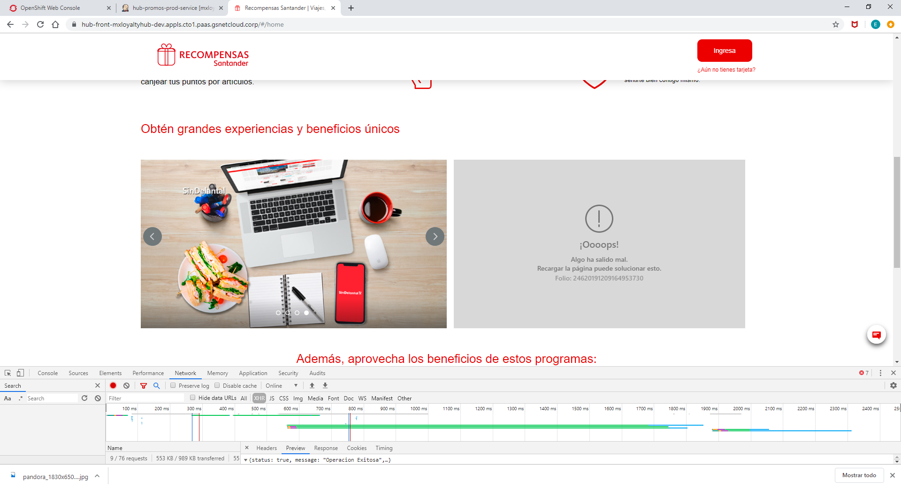

1. **Request URL:**

https://hub-front-mxloyaltyhub-dev.appls.cto1.paas.gsnetcloud.corp/public/promos-prod/sliders/PUBLIC_TWO

1. **Request Method:**

GET

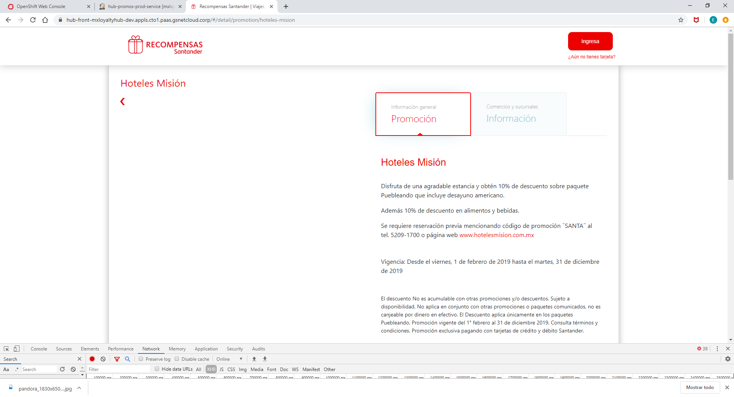

Request URL: https://hub-front-mxloyaltyhub-dev.appls.cto1.paas.gsnetcloud.corp/public/promotions/slugs/hoteles-mision

Request Method: GET

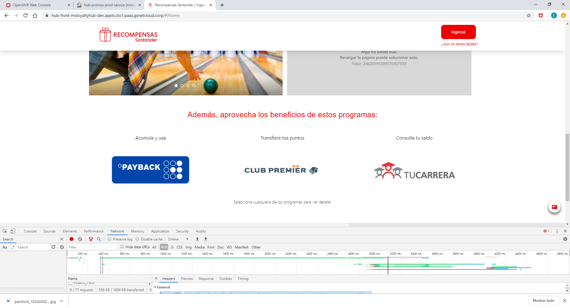

1. **Request URL:**

https://hub-front-mxloyaltyhub-dev.appls.cto1.paas.gsnetcloud.corp/public/tags/programs_sliders

1. **Request Method:**

GET

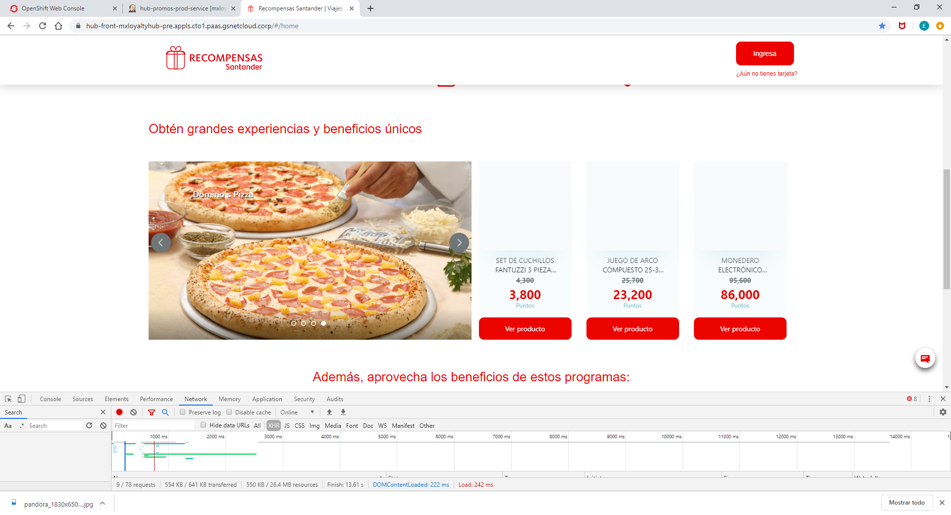

1. **Request URL:**

https://hub-front-mxloyaltyhub-pre.appls.cto1.paas.gsnetcloud.corp/public/products/sliders/three

1. **Request Method:**

GET

**Home Privado**

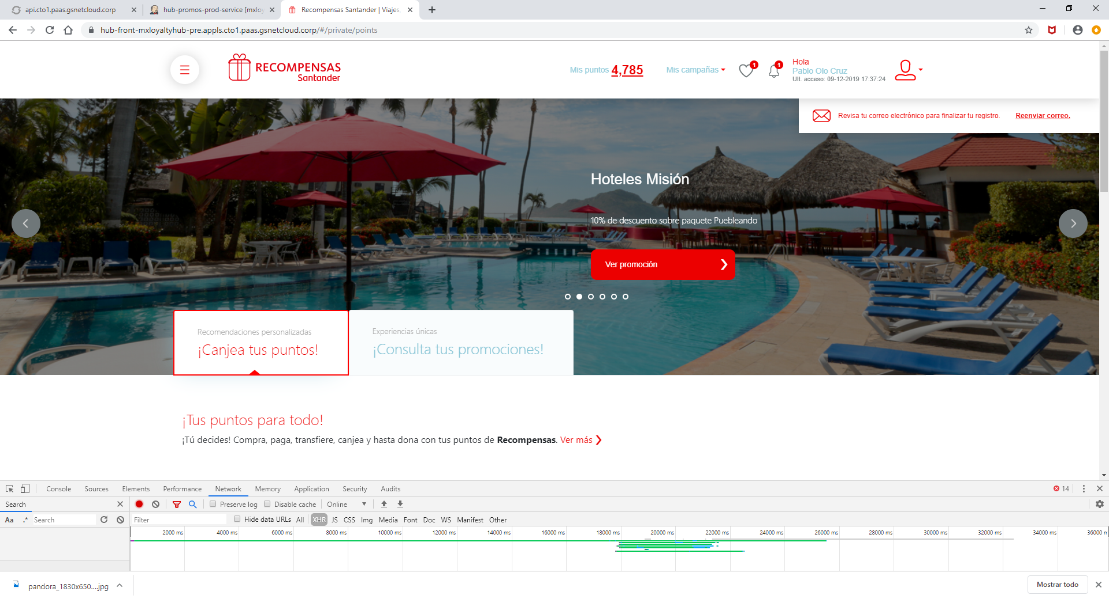

1. **Request URL:**

https://hub-front-mxloyaltyhub-pre.appls.cto1.paas.gsnetcloud.corp/private/promos-prod/sliders/ONE

1. **Request Method:**

GET

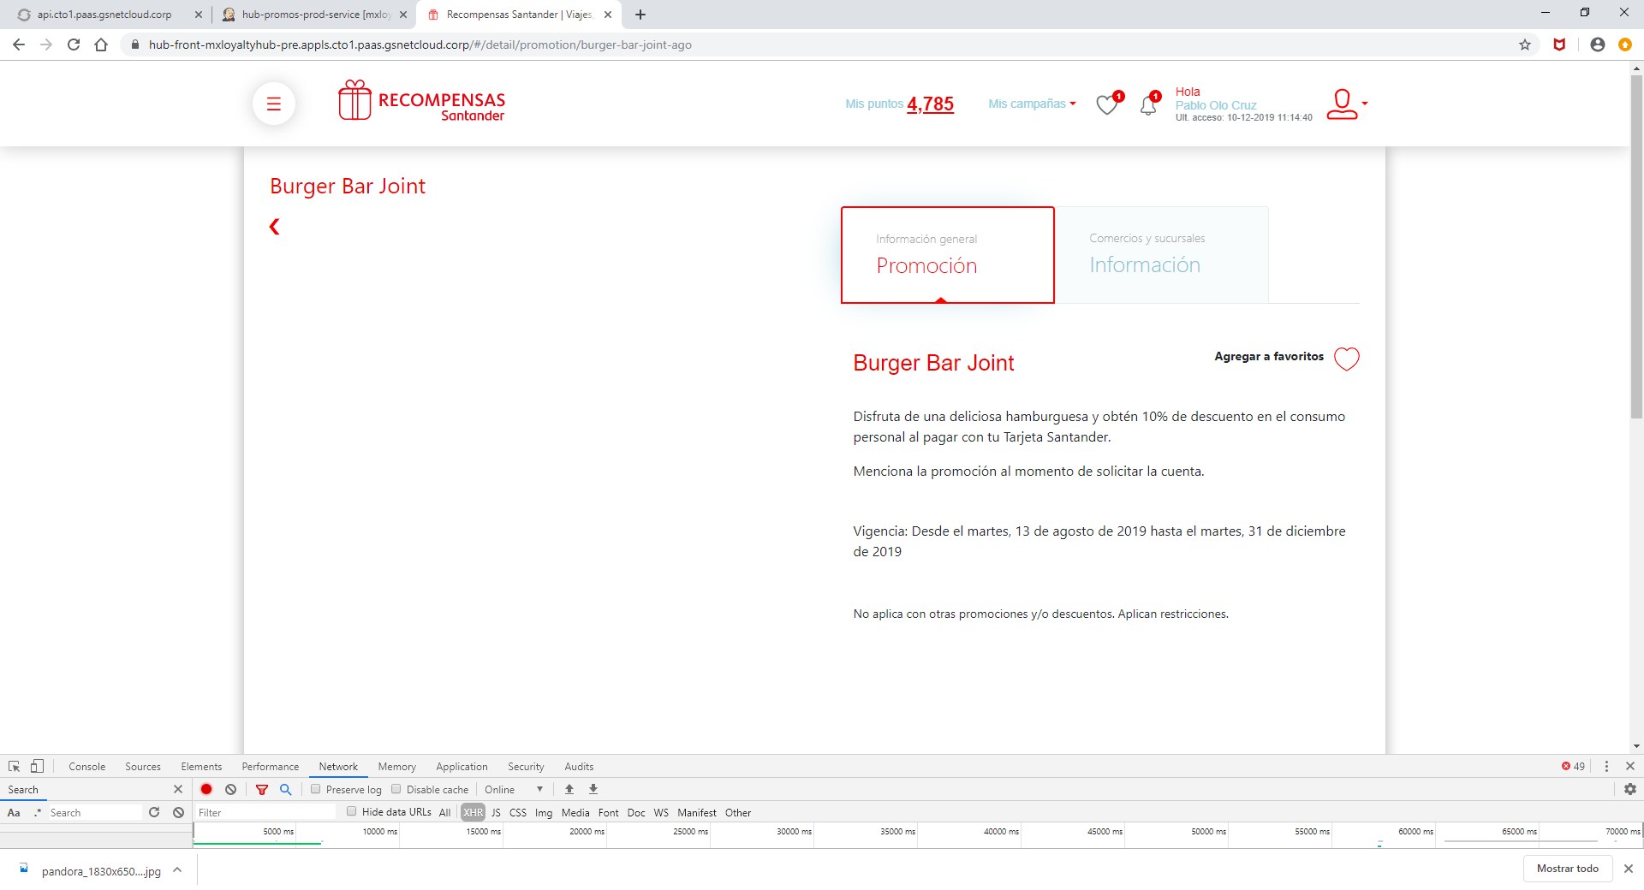

1. **Request URL:**

https://hub-front-mxloyaltyhub-pre.appls.cto1.paas.gsnetcloud.corp/private/promotions/slugs/burger-bar-joint-ago

1. **Request Method:**

GET

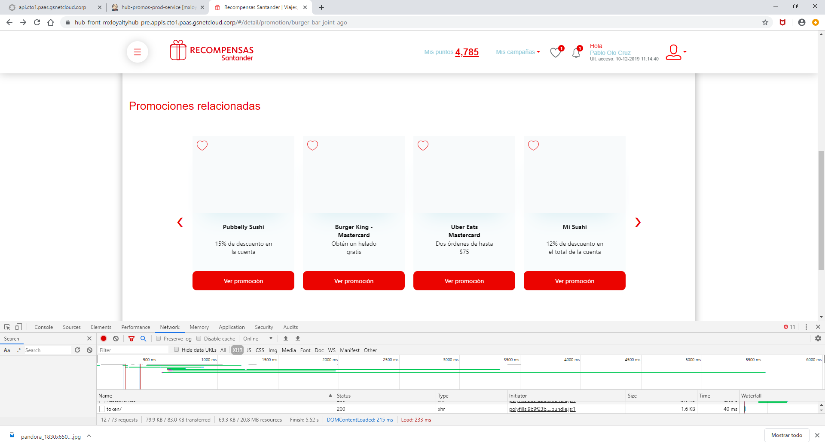

1. **Request URL:**

https://hub-front-mxloyaltyhub-pre.appls.cto1.paas.gsnetcloud.corp/private/promotions/categories/Restaurantes

1. **Request Method:**

GET

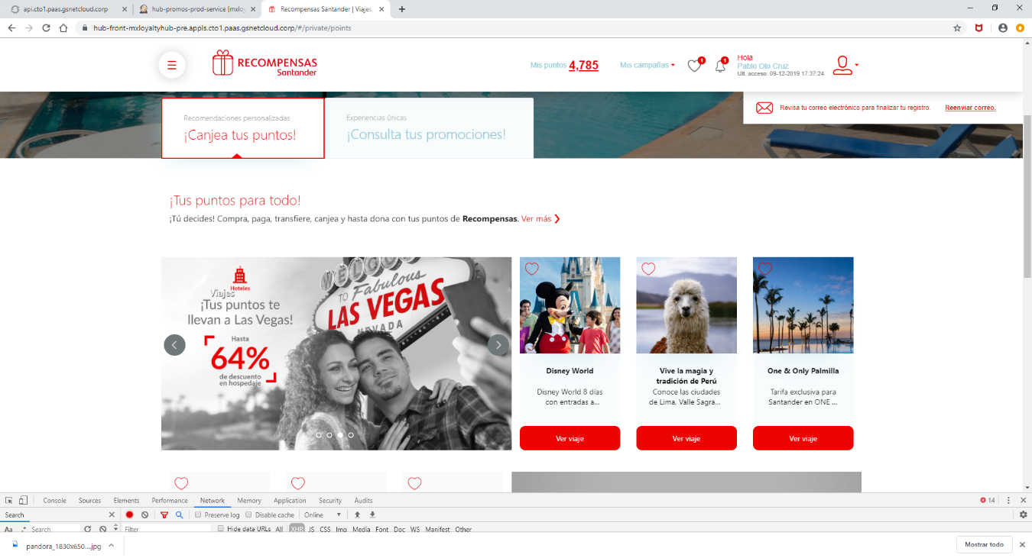

1. **Request URL:**

https://hub-front-mxloyaltyhub-pre.appls.cto1.paas.gsnetcloud.corp/private/tags/products/sliders/two

1. **Request Method:**

GET

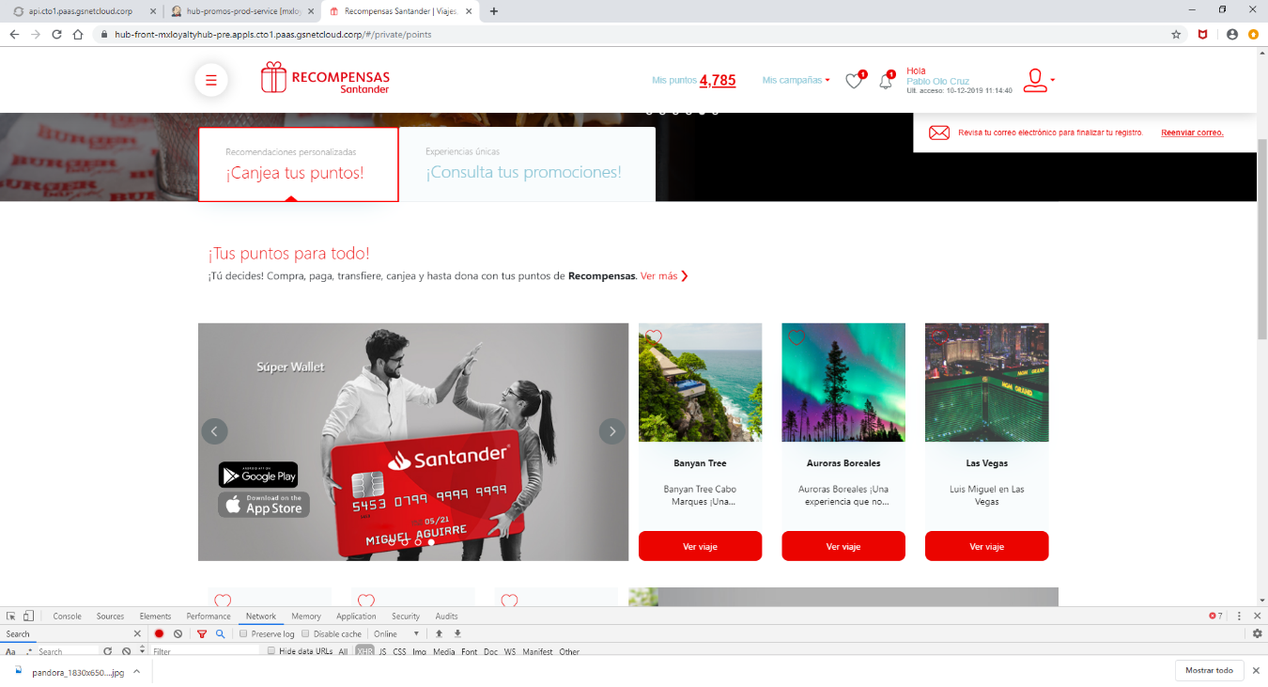

1. **Request URL:**

https://hub-front-mxloyaltyhub-pre.appls.cto1.paas.gsnetcloud.corp/private/travels/sliders/three

1. **Request Method:**

GET

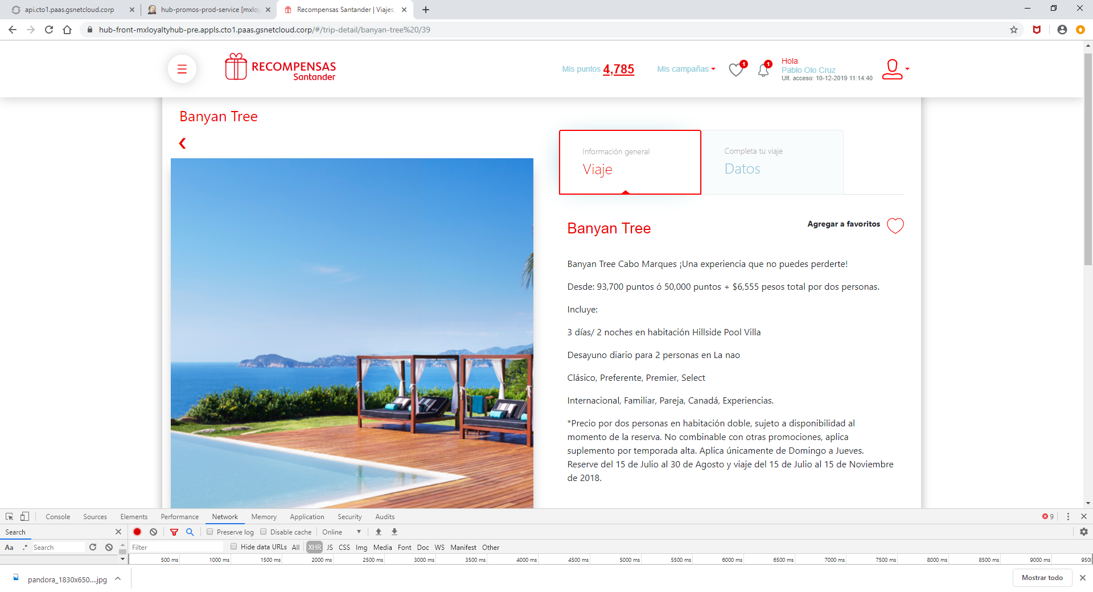

1. **Request URL:**

https://hub-front-mxloyaltyhub-pre.appls.cto1.paas.gsnetcloud.corp/private/travels/id/39

1. **Request Method:**

GET

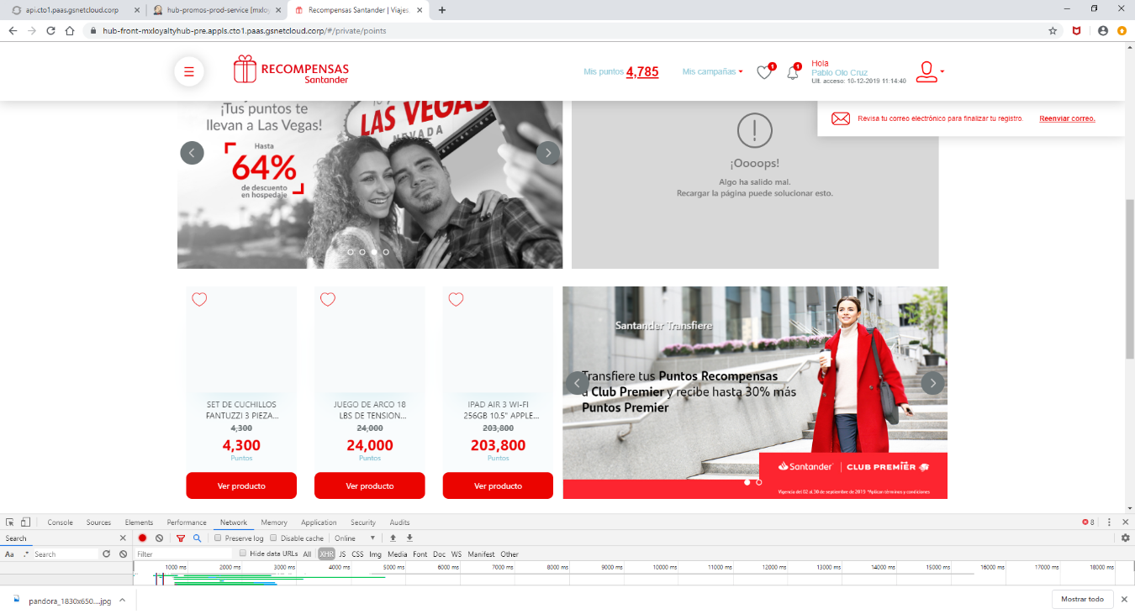

1. **Request URL:**

https://hub-front-mxloyaltyhub-pre.appls.cto1.paas.gsnetcloud.corp/private/tags/promotions/sliders/six

1. **Request Method:**

GET

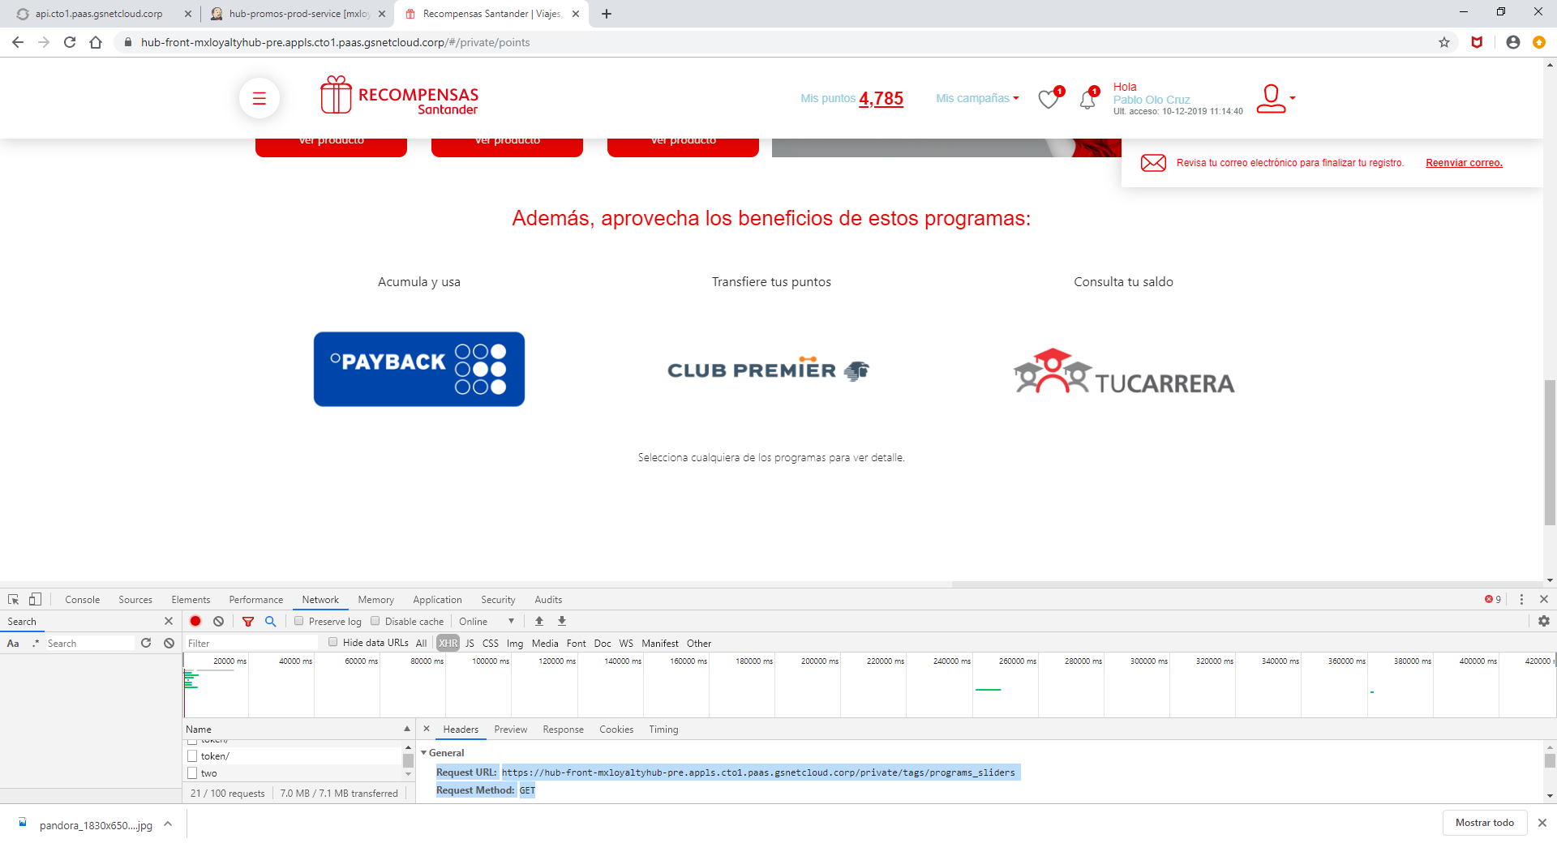

1. **Request URL:**

https://hub-front-mxloyaltyhub-pre.appls.cto1.paas.gsnetcloud.corp/private/tags/programs_sliders

1. **Request Method:**

GET

HOME PRIVADO PESTAÑA PROMOCIONES

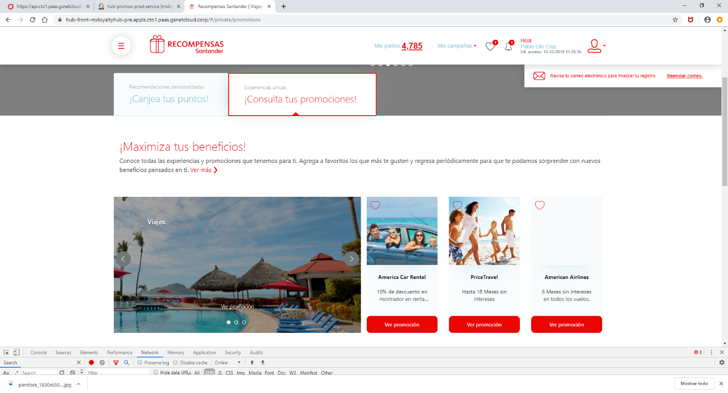

1. **Request URL:**

https://hub-front-mxloyaltyhub-pre.appls.cto1.paas.gsnetcloud.corp/private/promos-prod/sliders/CARDS_ONE

1. **Request Method:**

GET

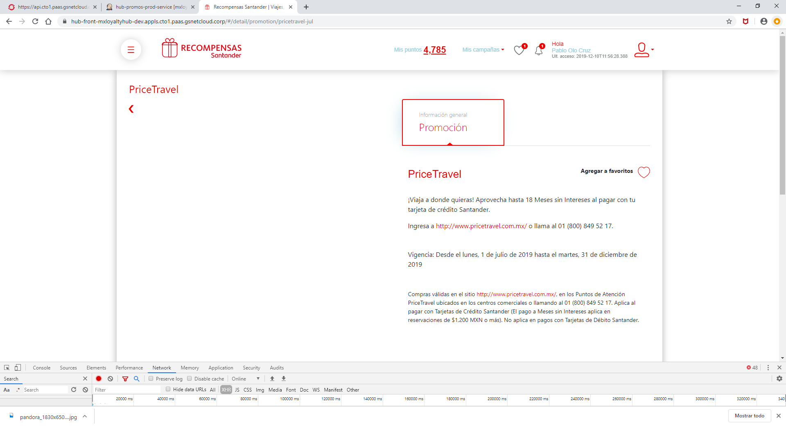

1. **Request URL:**

https://hub-front-mxloyaltyhub-dev.appls.cto1.paas.gsnetcloud.corp/private/promotions/slugs/pricetravel-jul

1. **Request Method:**

GET

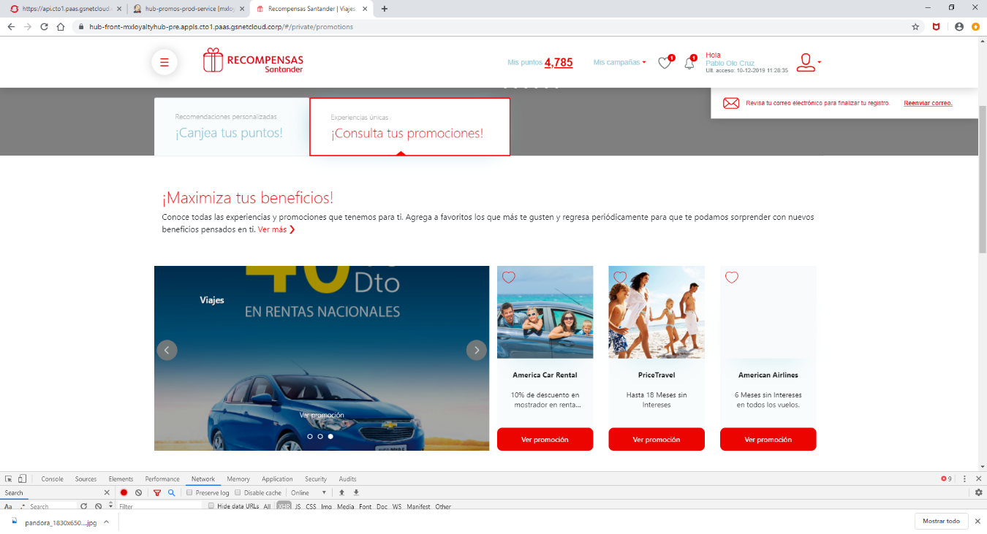

1. **Request URL:**

https://hub-front-mxloyaltyhub-pre.appls.cto1.paas.gsnetcloud.corp/private/promos-prod/sliders/TWO

1. **Request Method:**

GET

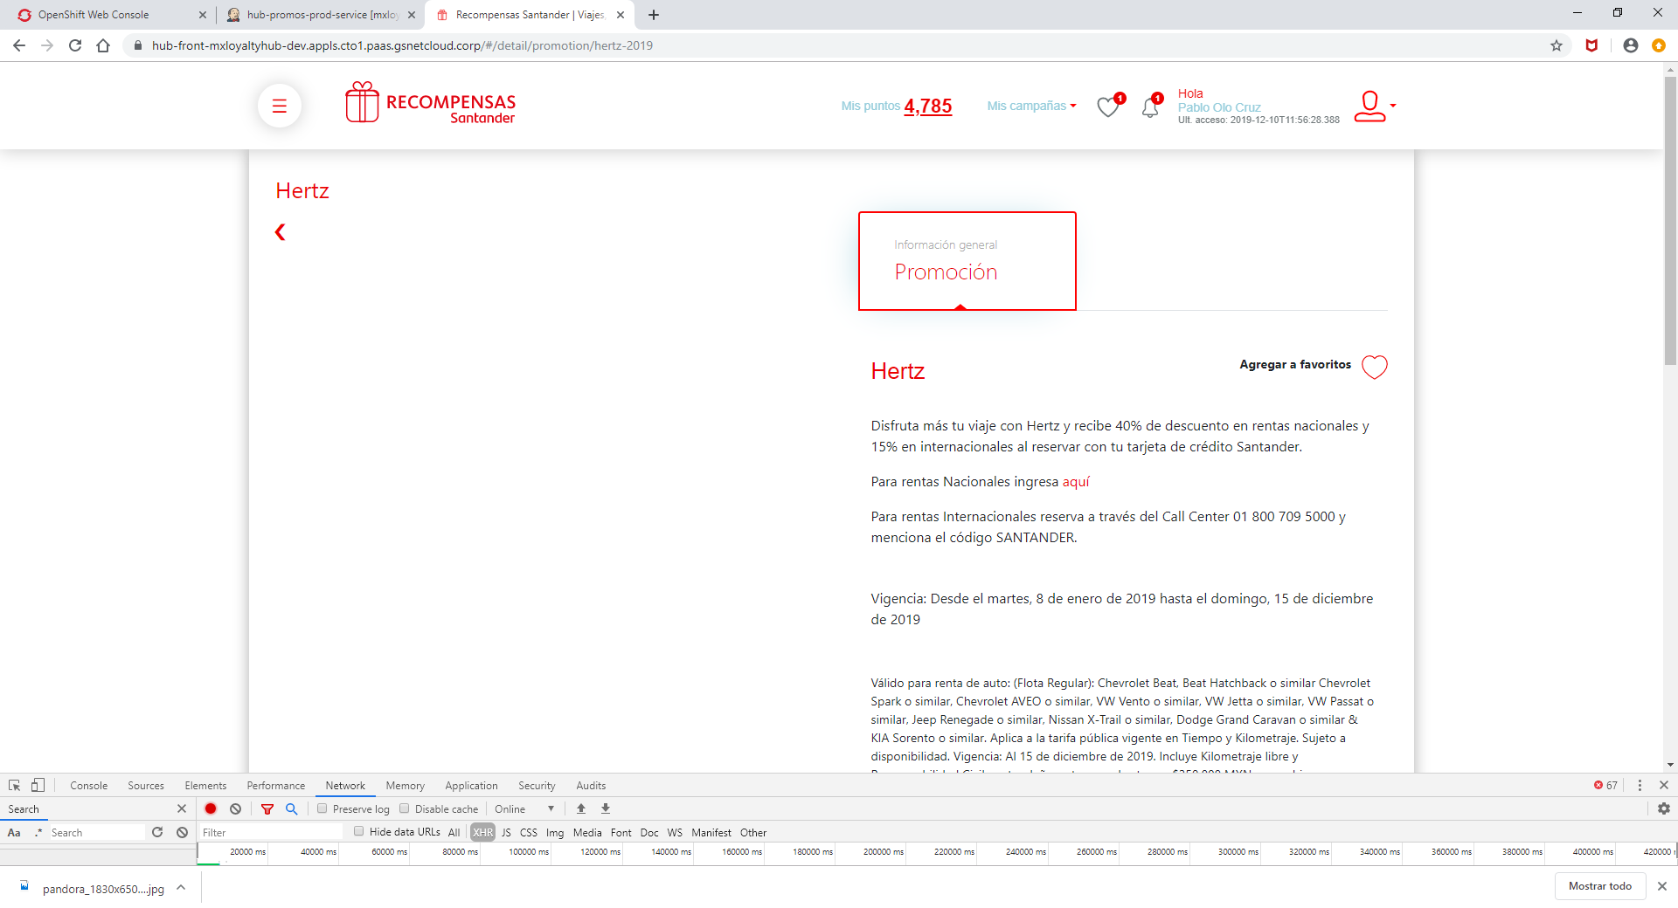

1. **equest URL:**

https://hub-front-mxloyaltyhub-dev.appls.cto1.paas.gsnetcloud.corp/private/promotions/slugs/hertz-2019

1. **Request Method:**

GET

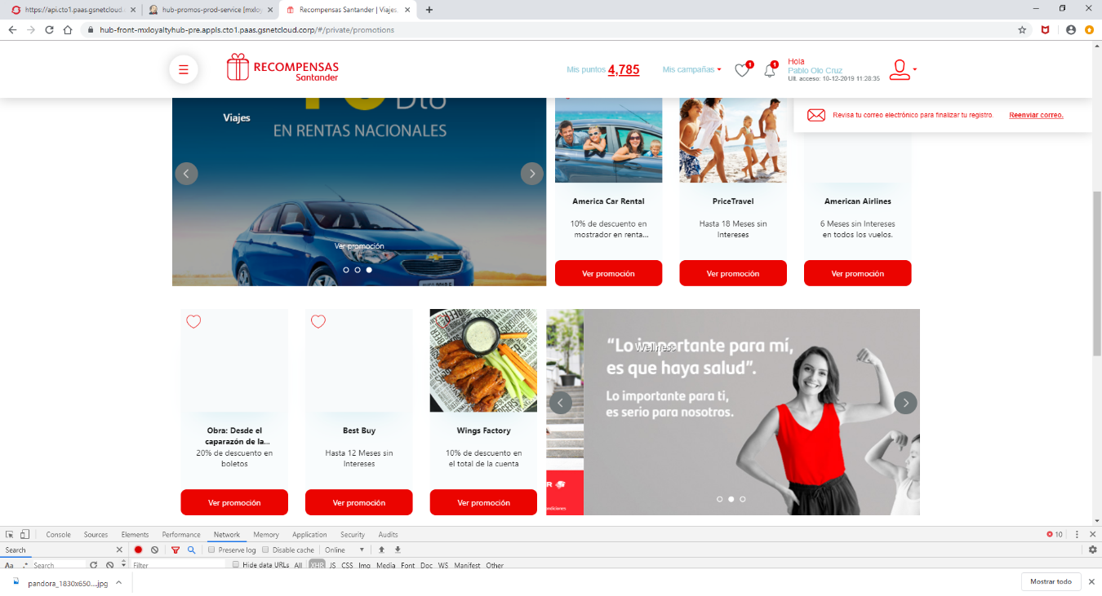

1. **Request URL:**

https://hub-front-mxloyaltyhub-pre.appls.cto1.paas.gsnetcloud.corp/private/promos-prod/sliders/CARDS_TWO

1. **Request Method:**

GET

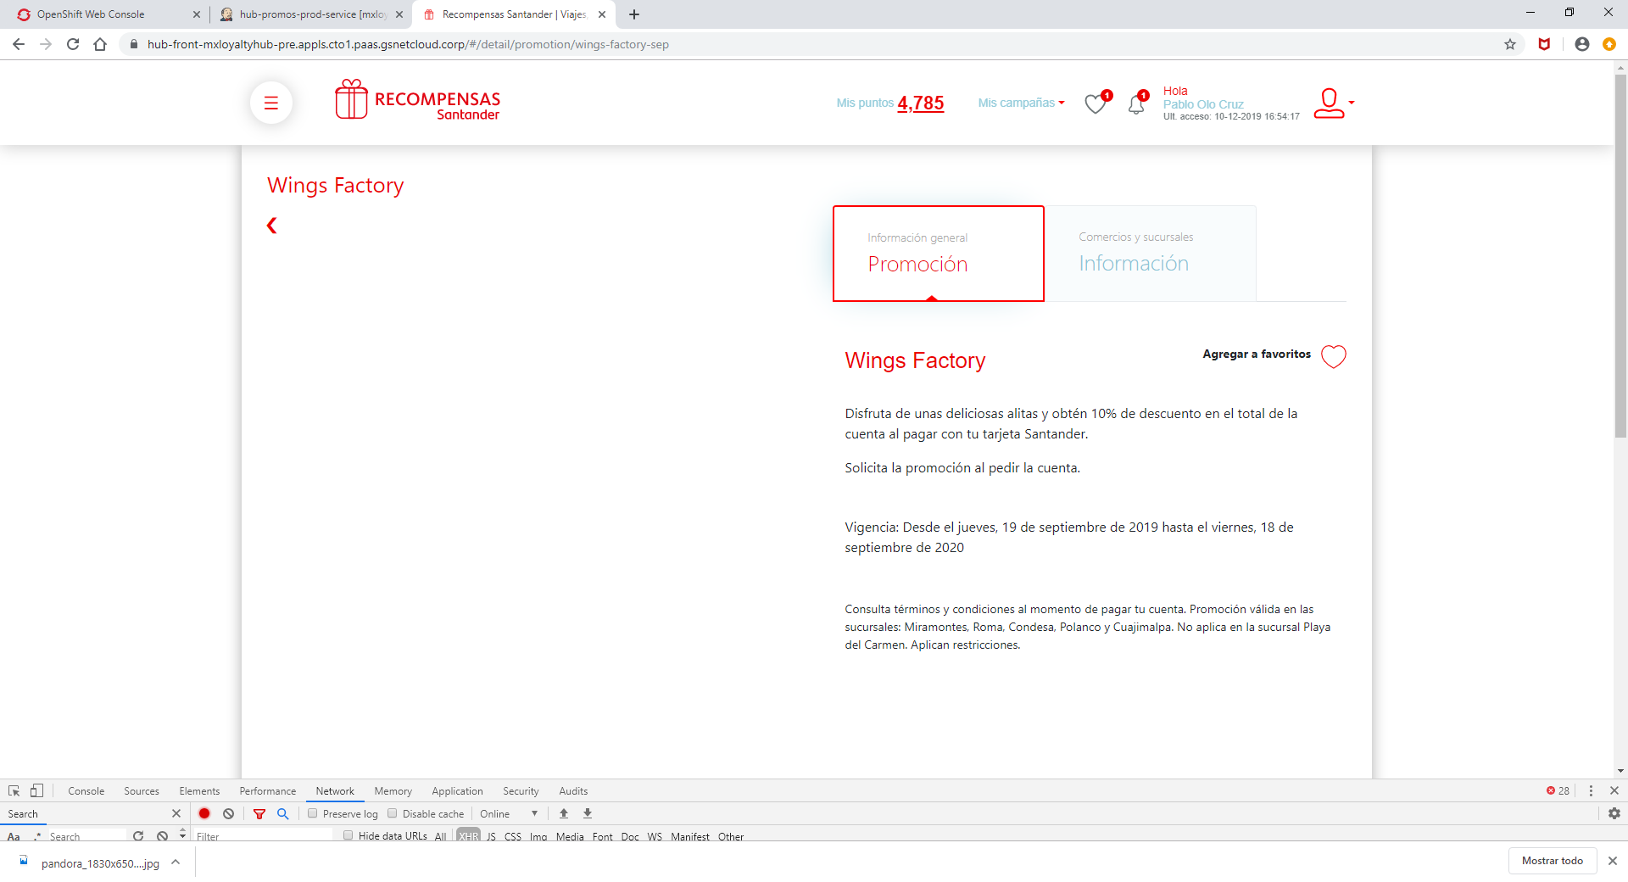

1. **Request URL:**

https://hub-front-mxloyaltyhub-pre.appls.cto1.paas.gsnetcloud.corp/private/promotions/slugs/wings-factory-sep

1. **Request Method:**

GET

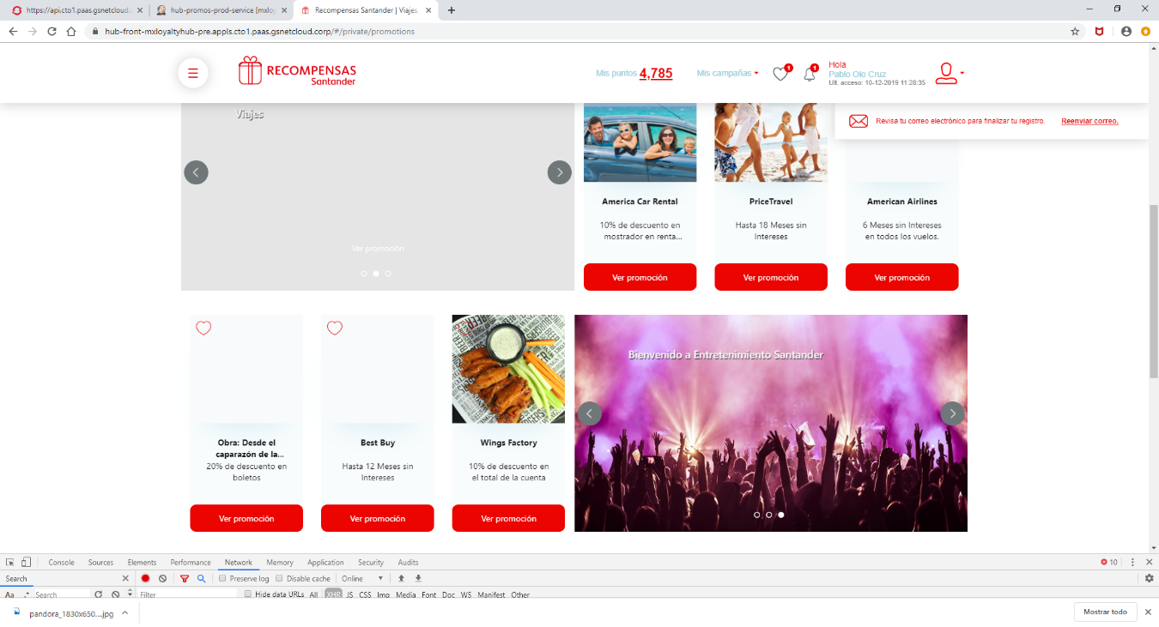

1. **Request URL:**

https://hub-front-mxloyaltyhub-pre.appls.cto1.paas.gsnetcloud.corp/private/tags/promotions/sliders/five

1. **Request Method:**

GET

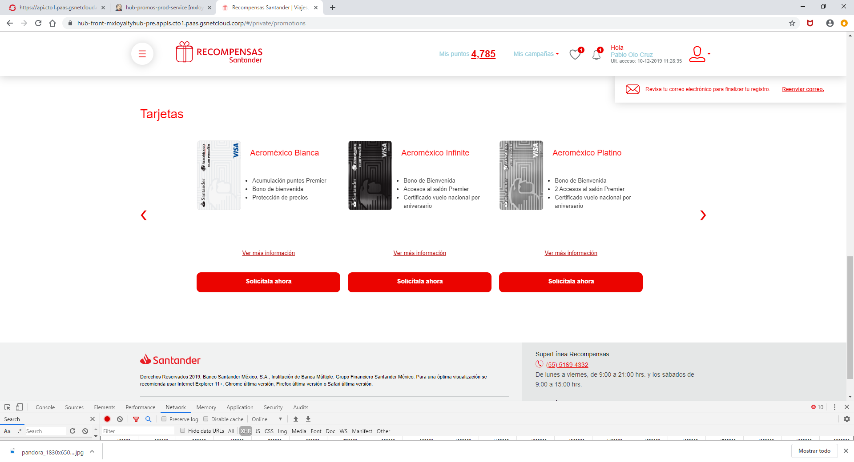

1. **Request URL:**

https://hub-front-mxloyaltyhub-pre.appls.cto1.paas.gsnetcloud.corp/private/tags/cards_list/carousels

1. **Request Method:**

GET